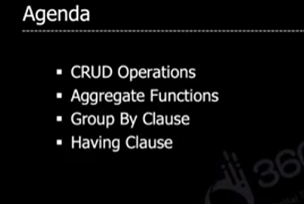

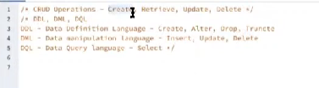

**Example for timestamp**

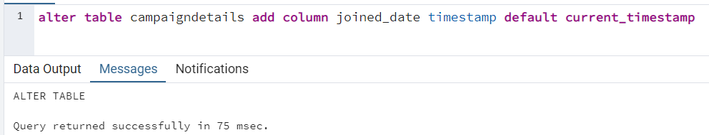

**Update record for multiple rows with in keyword**

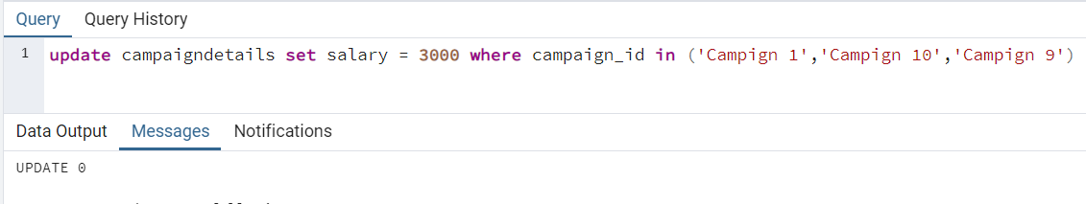

When we do update the timestamp we set for joined data is not updated for this we will have to use trigger.

**AGGREGATION**

**Count no of rows or record**

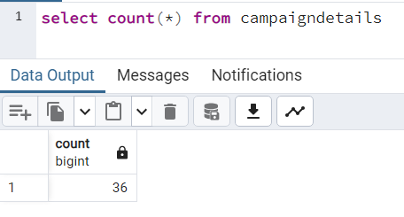

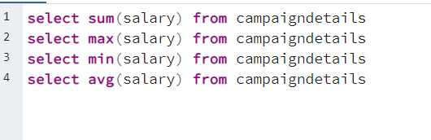

**Condition specification with !=**

We can use and, or

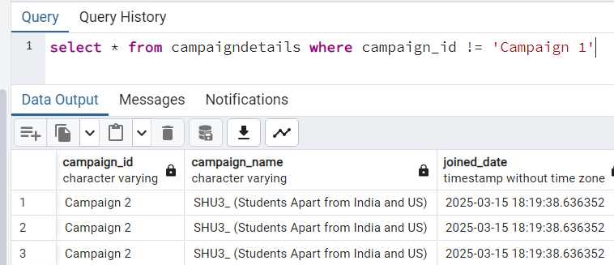

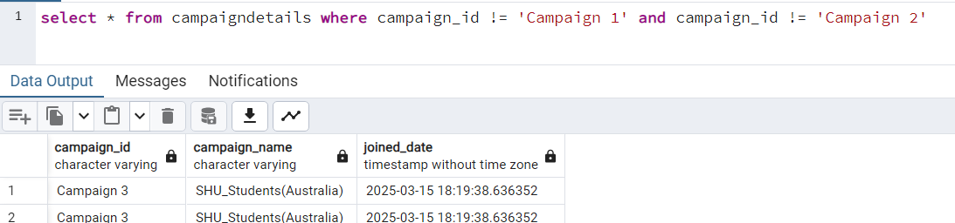

**GROUP BY**

Groups similar kind of record into a single bucket

EX: in below it groups all location into single bucket

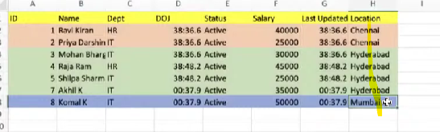

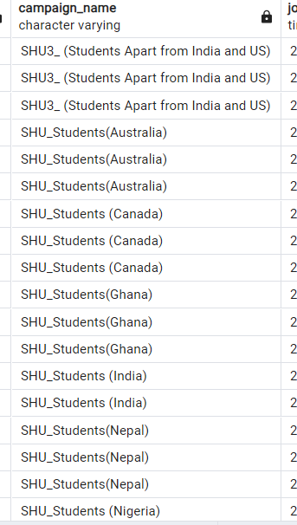

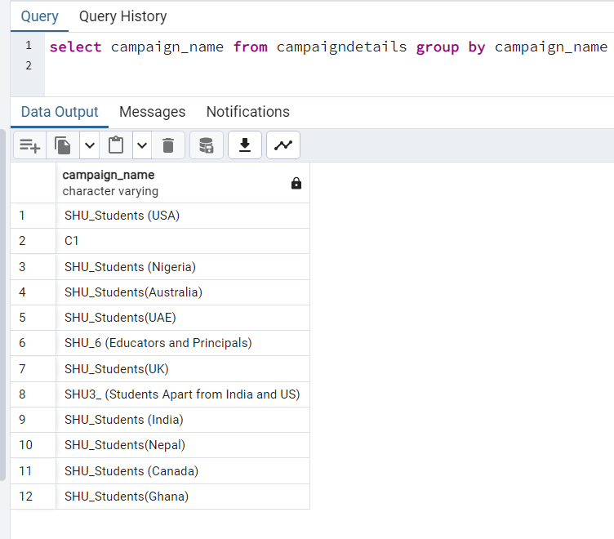

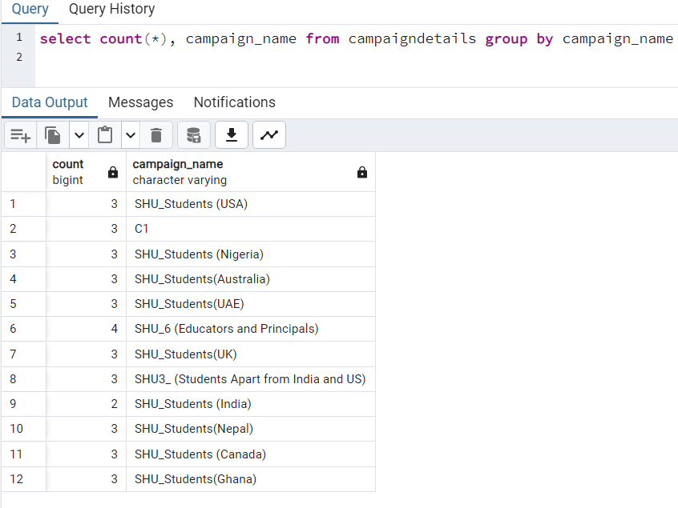

**Group by with more than one column**

In group by no of column we select should equal to the no of group by column, example if we select two column with one group by column it will throws error,

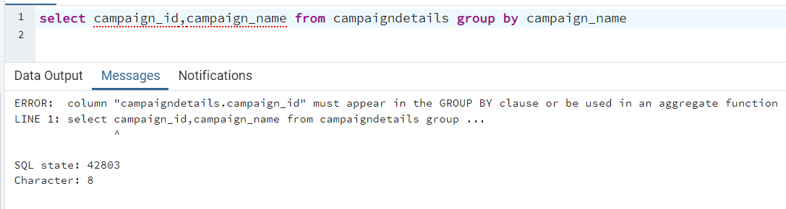

When we give more than one column on group it will group by both column

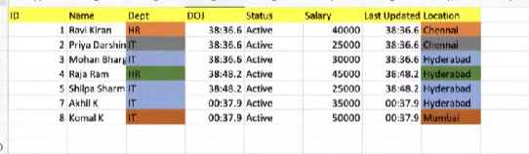

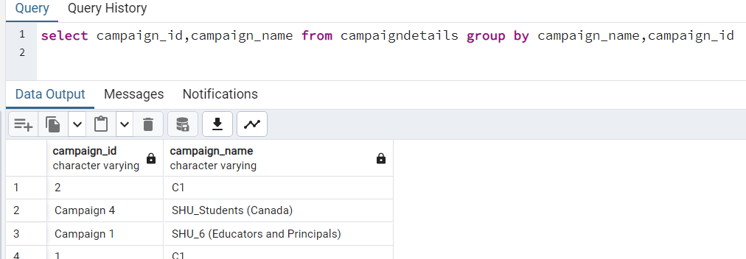

**Group by with where**

Putting where after group by will gives you error because where is applied before going to group the data, so where should be placed in before group by



Order of execution

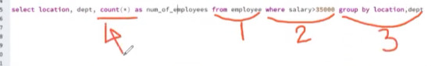

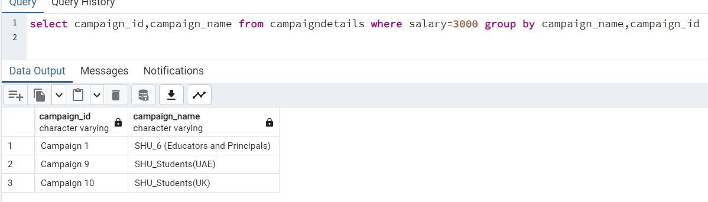

Below are the records which satisfies the where salary condition in above it groups this below records

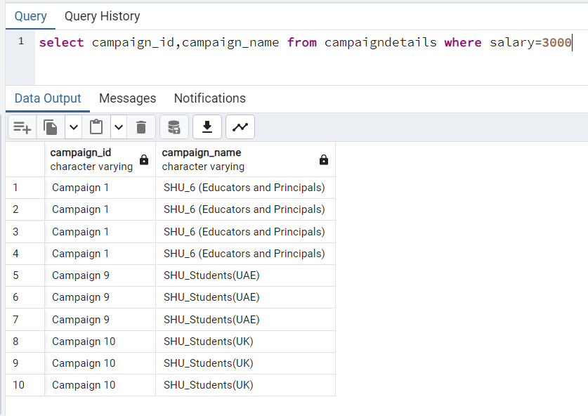

**HAVING**

Where is applied on row level data, but having is applied on after a specific function is applied. And also where will not work with aggregated functions while having will works. Don’t use having with single value like where it will take a lot of time to take it.

In the here example we take the data who’s campaign id is occurred more than 3 times

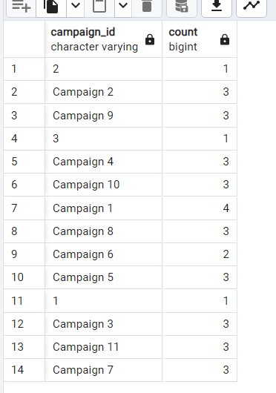

Campaign 1 it is

